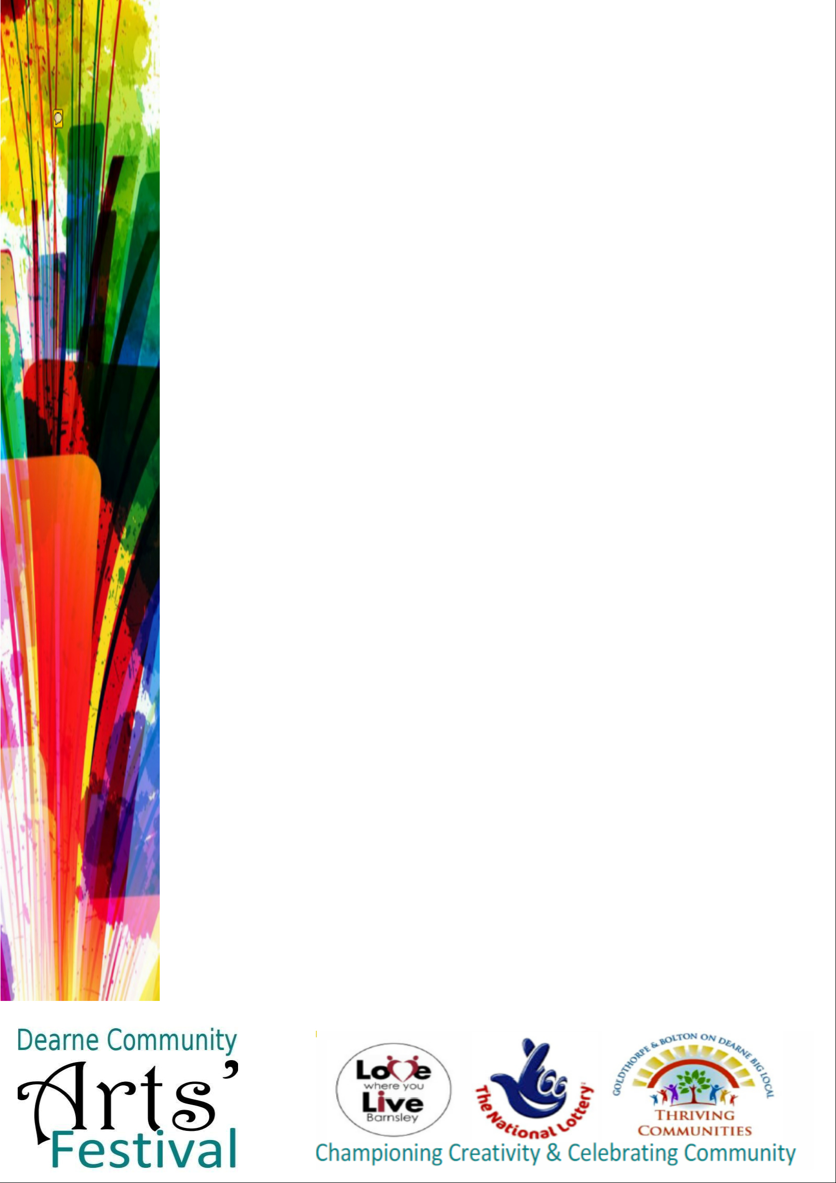

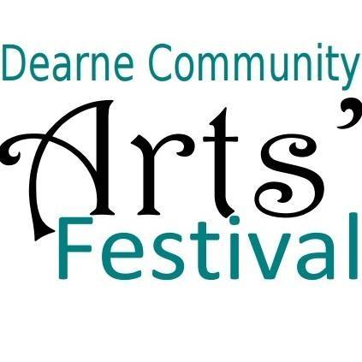

Friday 1st & Saturday 2nd September

11 a.m. – 5 p.m.

Dearne Playhouse,

Washington Road,

Goldthorpe, S63 9EF

For more information, contact Julie Turner on 07729 421405

or email [julie@gpcchurch.co.uk](mailto:julie@gpcchurch.co.uk).

Facebook page: <https://www.facebook.com/Dearne-Community-Arts-Festival>

*Please note items are subject to change or may be on one day only. Booking for Ian McMillan workshop is required.*

Light refreshments

Model aircraft flying display

3D Printing

Workshops

& demonstrations

Soft furnishings

Face painting

& body art

Karaoke in costume!

Dancing

Cake decorating

Floristry

Poetry

Fashion show

Live music

Wood carvings

Craft items

Photographs

Paintings

Free entry!