PEN PICTURES OF PARTNERSHIP MEMBERS

Alan George
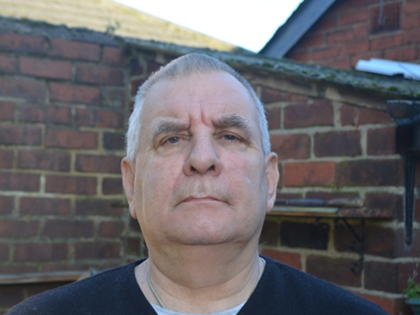
Alan is Chair of the Big Local Goldthorpe and Bolton on Dearne Partnership. Born in Darfield, he worked for 25 years as a colliery electrician and 20 years as a maintenance operative with regional railways. Alan served 37 years as a school governor, ran a youth group [Church Lads Church Girls Brigade ] for 40 years and is presently treasurer of The Dearne Ward Alliance, Dearne Labour Party, Dearne Active Community Group and is a director of the renaissance centre.

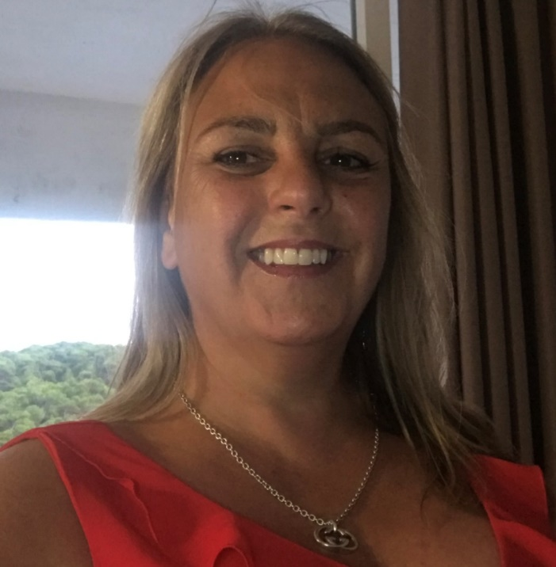
Dorothy Coates
Dorothy was born and still lives in Barnsley. By profession Dorothy is a teacher who specialises in SEND and has been a community volunteer for over 30 years, currently she is currently one of the three elected members for the Dearne South Ward in Barnsley.
Much of Dorothy’s spare time is spent with her family and friends and she enjoys travelling. She joined the Goldthorpe and Bolton on Dearne Big Local Partnership in 2021.

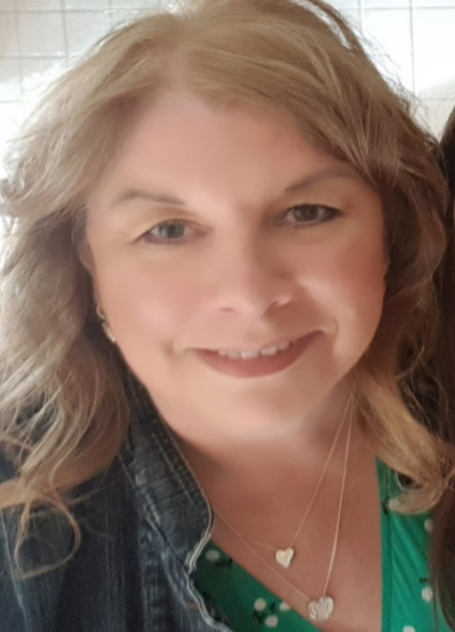
Gill Richmond
Gill has worked in the Third sector for over twenty years in project management, training and teaching and takes great satisfaction in development work, searching for funding and empowering communities to take ownership and have an impact in their local area. Living in Sheffield but having a love for the Barnsley area lead her to gravitate towards the Dearne and forge links with many projects as a volunteer. She now works for The Stroke Association, a national charity, and is seconded to the NHS in Barnsley. In her spare time she loves cooking, gardening and spending quality time with friends and family.
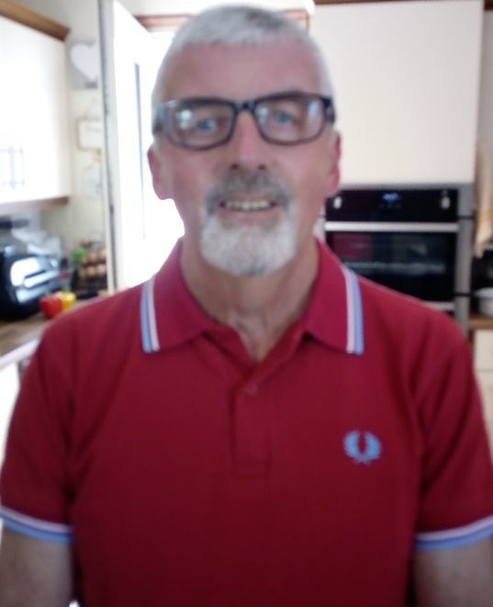
Neil (known as Sam) Danforth
Sam is an Independent Councillor representing Dearne South Ward. He I am also a school governor at Lacewood Primary School, Bolton on Dearne.
Sam has lived in the Dearne area all his life. He was born in Goldthorpe and moved to Bolton on Dearne after getting married in 1981. He worked at Goldthorpe Colliery for 25 years. Sam has been a member of a local volunteer group Bolton on Dearne Voluntary Action Group (BODVAG) for many years. Among other things he is active doing litter picking and events for the local community.

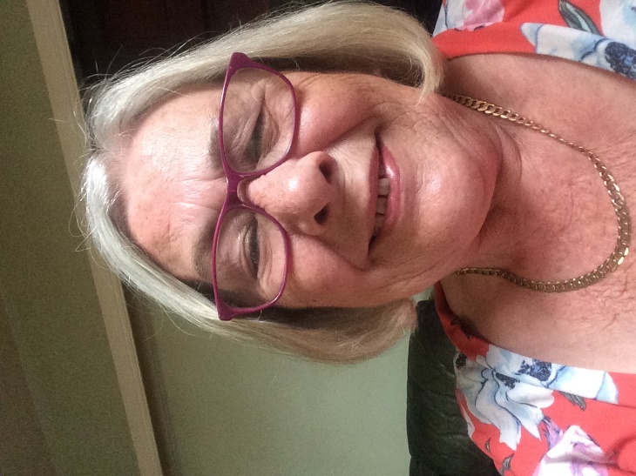
Pat Hubery
Pat was born in Mexborough and attended Mexborough Grammar school. She went on to work for Yorkshire Bank up to having the first of her 4 children. In 1980 she and her husband bought a fish and chip shop on Dearne Road in Bolton and she has run it ever since. She is always willing to help anyone where she can and is Secretary to Dearne South Labour Party and also on the Ward Alliance team.

Anita Heatherglen
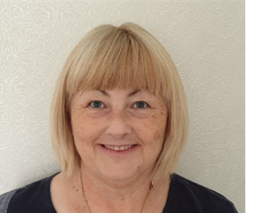
Anita has been a part of the Goldthorpe and Bolton on Dearne Big Local since applying for funding to establish a community café in September 2016, and officially took on the role of LTO in October 2020.
Prior to this Anita had been a SEN Tutor at Barnsley College working with 16 – 24-year-olds with physical disabilities, learning difficulties and challenging behaviours.
Anita has been involved in voluntary work for many years including being a Scout Leader, organising and running a youth club, working as a driver/escort for MENCAP, and working with young offenders delivering Literacy and Numeracy programmes.
Anita has been married for over 40 years and has two children and six grandchildren. She enjoys reading, knitting, and sewing.

Dennis Hogg.
Dennis has been a resident of Goldthorpe for 31yrs. He married to a Hickleton girl. A Sheffielder ( DeeDar) by birth, he was a former Manager of a Transport company ( 40yrs) and former Referee Tutor for Football Association for 15yrs.
His ambition is to make the area a better place to live for everyone. Littering is his main bug bare.
His interest are: Family, Football, Travelling and Holidays.

In Support……….
Darryl Hand
Darryl is a resident of Thurnscoe and has lived there all of his life. He has spent a lot of his time volunteering in the Dearne and been actively involved in many community projects. He has a natural and genuine invested into his community and now works as a Neighbourhood Engagement Officer for Barnsley Council. He’s often found at Gigs or Festivals watching his favourite bands and well known as a bit of foodie.

Jenny Yates
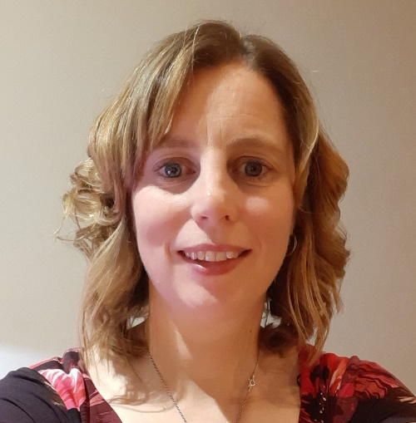
Jenny has worked for BMBC as a Community Development Officer for the Dearne Area Team since December 2020. It was a welcome return to the Dearne and its people having been a Community Development Worker in the area around 20 years ago. She is passionate about engaging with communities to build their confidence and capacity and particularly enjoys projects that improve the local environment and encourage an active and health lifestyle. Jenny herself enjoys being active and regularly runs, cycles, walks and swims in her spare time. Watch out for her running about the local greenspaces in the Dearne!

Stacey Turner
Stacey and moved to Goldthorpe 6 years ago when she got married. She can often be found volunteering at the local church events or attending groups and activities. Having previously worked in the reception of Sacred Heart Primary School and as a self-employed accountant she joining the Snap Tin Community hub as the BL support worker.

Stacey enjoys being outdoors making memories with her family and friends, taking photographs and exploring. She is always up for a new adventure and challenge.

